-3ZAPractice Problems
1. The probabilities that a service station will pump gas into 0, 1, 2, 3, 4, or 5 or more cars during a certain 30-minute period are 0.03, 0.18, 0.24, 0.28, 0.10, and 0.17, respectively. Find the probability that in this 30-minute period
(a) more than 2 cars receive gas.
(b) at most 4 cars receive gas.
(c) 4 or more cars receive gas.
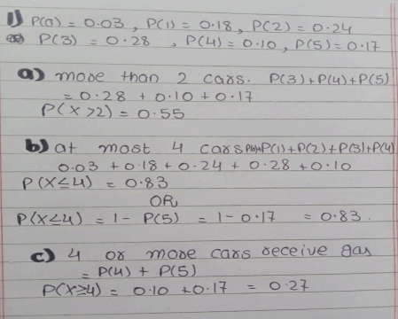

2. An industrial plant is conducting a study to determine how quickly injured workers are back on the job
following injury. Records show that 10% of all injured workers are admitted to the hospital for treatment and 15% are back on the job the next day. In addition, studies show that 2% are both admitted for hospital treatment and back on the job the next day. If a worker is injured, what is the probability that the worker will either be admitted to a hospital or be back on the job the next day or both?
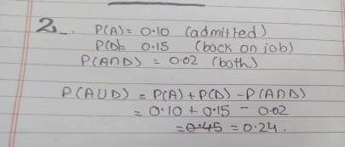
3. Police plan to enforce speed limits by using radar traps at four different locations within the city limits. The radar traps at each of the locations L1, L2, L3, and L4 will be operated 40%, 30%, 20%, and 30% of the time. If a person who is speeding on her way to work has probabilities of 0.2, 0.1, 0.5, and 0.2, respectively, of passing through these locations, what is the probability that she will receive a speeding ticket? If the person received a speeding ticket on her way to work, what is the probability that she passed through the radar trap located at L2?
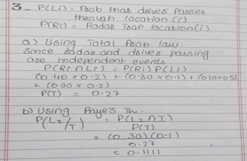
4. A large industrial firm uses three local motels to provide overnight accommodations for its clients. From past experience it is known that 20% of the clients are assigned rooms at the Ramada Inn, 50% at the Sheraton, and 30% at the Lakeview Motor Lodge. If the plumbing is faulty in 5% of the rooms at the Ramada Inn, in 4% of the rooms at the Sheraton, and in 8% of the rooms at the Lakeview Motor Lodge, what is the probability that
(a) a client will be assigned a room with faulty plumbing?
(b) a person with a room having faulty plumbing was assigned accommodations at the Lakeview Motor Lodge?
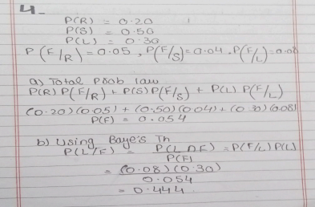
5. A certain form of cancer is known to be found in women over 60 with probability 0.07. A blood test exists for the detection of the disease, but the test is not infallible. In fact, it is known that 10% of the time the test gives a false negative (i.e., the test incorrectly gives a negative result) and 5% of the time the test gives a false positive (i.e., incorrectly gives a positive result). If a woman over 60 is known to have taken the test and received a favorable (i.e., negative) result, what is the probability that she has the disease?
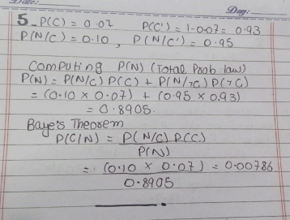
6. A rare disease exists with which only 1 in 500 is affected. A test for the disease exists, but of course it is not infallible. A correct positive result (patient actually has the disease) occurs 95% of the time, while a false positive result (patient does not have the disease) occurs 1% of the time. If a randomly selected individual is tested and the result is positive, what is the probability that the individual has the disease?
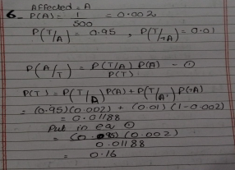
7. Consider a company’s website composed of more than 4 web pages. The company tracks the use of its web site and has determined that the more pages visitors view, the more likely the visitors are to provide contact information. Use the following table to answer the given questions:
Number of pages viewed | 1 | 2 | 3 | 4 or more
Percentage of visitors | 40 | 30 | 20 | 10
Percentage of visitors that provide contact information after visiting given number of web pages of the website | 10 | 1  0 | 20 | 40

a) What is the probability that a visitor to the web site provides contact information? b) If a visitor provides contact information, what is the probability that the visitor viewed four or more pages?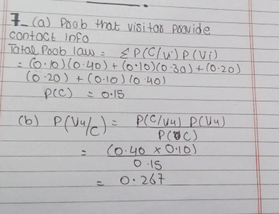
8. A company has 200 workers, and it is known that 30% of the workers have high blood pressure problem. A medical inspection team randomly selects 20 workers and tests them. What is the probability of having exactly 5 workers with high blood pressure issue?
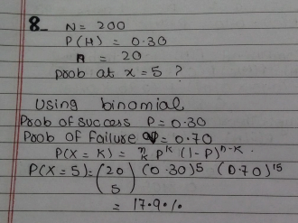

9. The time it takes a cell to divide (called mitosis) is normally distributed with an average time of one hour and a standard deviation of 5 minutes.
(a) What is the probability that it will take a cell more than 65 minutes to divide? (b) What is the time that it takes approximately 99% of all cells to complete mitosis?
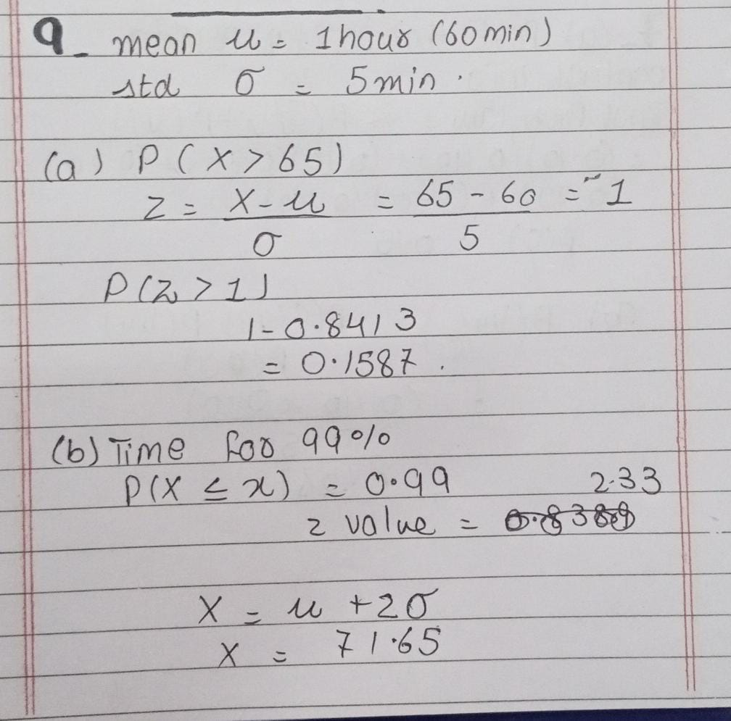
10. Suppose that we visit a certain bank in the busy hour, 10:00am to 11:00am, daily. Let the number of people arriving at a queue in the bank follows the Poisson distribution with a mean of 5 people per 10 minutes in that busy hour. If exactly 30 people arrive in the busy hour, we call it as peak hour. a) What is the probability of having a peak hour in single visit?
b) If we visit the bank for 30 days and all visits are independent, what is the probability that out of 30 there are exactly 4 visits when a peak hour occurs?
c) What is the expected number of peak hours in 30 visits?
d) What is the probability that it is your 10th visit when you first time get a peak hour? e) What is the probability that you will have to do exactly 20 visits to the bank to observe 5 peak hours?
f) What is the expected number of visits you need to make to observe 5 peak hours?